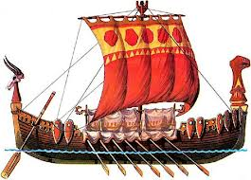
Anglo-Saxon Period
Literary Terms

Oral poetry

Scop

heroic tradition

elegiac tradition

epic

riddle

rhythm

alliteration

caesura

kenning

theme

hyperbole

epithet

