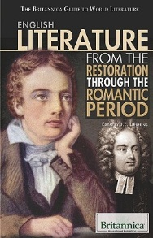
British Literature
17th, 18th, and early 19th Centuries—Age of Reason and Romantic Period

Read the pages in the textbook that are identified for you and answer the following questions completely:

Pages 252; 272
Define sonnet:

Define Petrarchan (or Italian) sonnet:

Define Shakespearean sonnet:

Pages 466-467; 480-481; 494; 504; 518-519
Briefly describe the civil war and period after in British history. Who was king? Who went against him? What were the political parties that were formed?

What was the “Glorious Revolution”?

What was the second revolution to happen in this time period and how was it started?

Who was John Donne? (Briefly summary what you have read on page 481.)

Define conceit:

Define paradox:

Define lyric poem:

Define the term “carpe diem”:

Who was John Milton? (Briefly summary what you have read on pages 518-519.)

What inspired the changes during the Romantic period of British history? What changes were made (from what to what?)

Pages 716; 818; 880
Define the following literary/poetry terms:
Narrative poetry:

Alliteration:

Consonance:

Assonance:

Internal rhyme:

Ode:

