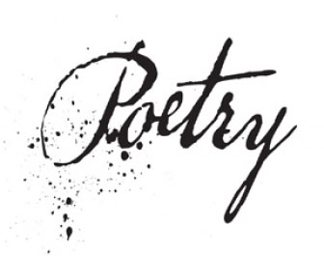
17th and 18th Centuries and the Romantic Period
(p. 480-481)
John Donne): He wrote the following poem in 1611 for his wife Ann More when he was about to embark on a trip to France and Germany.
- Define Metaphysical poetry:

- Define Conceit:

Read “A Valediction: Forbidding Mourning” (p. 484-485). As you read, discuss the meanings and interrelationships of the stanzas.

- What is the speaker’s situation and motivation throughout the first five stanzas?

- What is the unusual comparison in this poem? (What is the conceit?)

- Act out the image in the conceit. What message about their relationship does the speaker indicate with this comparison?

Carpe Diem! In the 17th century poets (the male ones!) used this theme in their poetry. The lyric poems used witty puns and fanciful imagery to try to convince females to take advantage of the opportunity for love.

Read “To His Coy Mistress” by Andrew Marvell (p.484-485)
- Define the word “coy”:

- Name three things the speaker and his mistress would do and the time it would take for each if time were not an issue.

- Explain the metaphor “time’s winged chariot” (line 22).

- What future does the speaker see for himself and his love in lines 21-30?

- Assignment: write a short poem. In your poem, the speaker is the lady in Marvell’s poem. How does she answer the speaker of “To His Coy Mistress?” You may write this below or on a separate sheet of paper.

The Romantic Poets
- What are the consistent themes and attitudes of Romantic poets? (See page 725)

William Blake (p.747)
- What are the two anthologies of poetry that he wrote?

“The Lamb” (p.748)
- From which anthology is this poem? How do you know?

“The Tyger” (p.749)
- This poem asks a series of questions. What is the general context of these questions?

- Line 20 refers to the poem “The Lamb.” Paraphrase this question. (What does the speaker really want to know?)

- From which anthology does this poem come? How do you know?

- Write a paragraph comparing the two poems.

