Notes on Chaucer and The Canterbury Tales
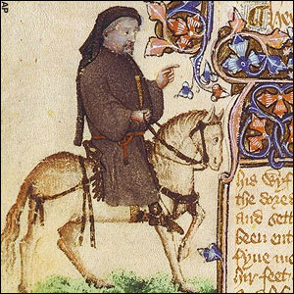
Take note on pages 90-91 and 92-95, using these guided questions:
Explain Chaucer’s premise for The Canterbury Tales.

Discuss the three ranks of medieval society that Chaucer surveys.

Explain about the types of stories each of the pilgrim tells.

Who is Geoffrey Chaucer and when did he live?

Who is Thomas a Becket and why is he important?

Posthumously, how does the world feel about Chaucer and how do we know?

